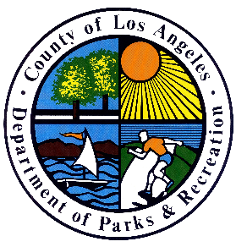
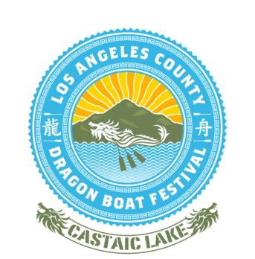
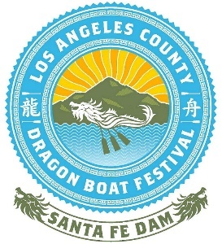
2022 LOS ANGELES COUNTY CASTAIC LAKE
DRAGON BOAT FESTIVAL
TEAM ROSTER

TEAM NAME:
DIVISION:

PLEASE COMPLETE ENTRIES AS SHOWN IN THE EXAMPLES BELOW. Please list each team member, alphabetically by last name. All information is required.

Completed rosters are to be submitted by May 31, 2022 along with copies of the signed waiver.
No. | Last Name | First Name | Gender | Position  (Drummer / Paddler / Alternate / Steers)
EX | Doe | Jane | F | Drummer
01
02
03
04
05
06
07
08
09
10
11
12
13
14
15
16
17
18
19
20
21
22
23
24
25

I certify that each team member on this roster has read, understood, and signed a waiver, and is eligible to participate in this event.

Signature of Team Captain: Date:

